Shot Controls Overview (2024/9/17)
The shot control mechanics in GolfIn involve several stages, each of which influences various aspects of the shot, such as accuracy, spin, and power. These controls combine intuitive drag-and-flick actions with visual feedback to enhance player interaction.

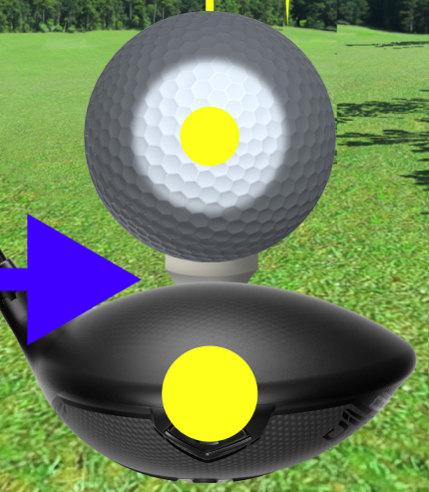
Pre-Stage (Optional, entered through the Spin button)

Ball Spin Selection:
Players can set the desired point of impact on the ball to control its spin (e.g., top spin, backspin).
The selection area is influenced by the spin parameters of the club and ball. (e.g. the higher parameters the lesser the gray zone is. You can’t select a point in the gray zone.)
Default setting: The center of the ball.
Players can restore the default position by long tap on the ball.
Impact:
Spin affects ball trajectory, post-impact and post-landed behavior (e.g. counter-clockwise spin of the ball that was hit by a right-handed player gives longer ground-run after hitting the ground (draw ball))
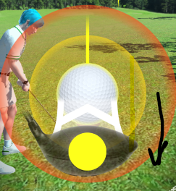
1st Stage: Pulling the Club (Setting Power & Trajectory)

Mechanics:
Action: Tap the club, hold it, and drag your finger downwards to initiate the swing.
Controls:
Power Control: The further the club is pulled down, the more power is generated, influencing flight distance. This is based on the combined power parameters of the club and ball.
Trajectory Adjustment: Pulling to the left or right affects the direction; the ball will move in the direction according to the implemented real golf physics (spin point + direction of swing).
Important Considerations:
Power Reset: Releasing your finger prematurely will reset the power back to 0%, requiring the player to start the pull again. This allows for adjustments before committing to the shot.
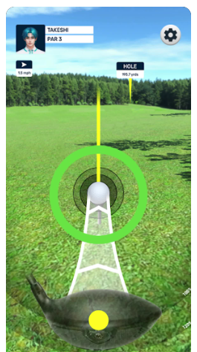
Slow Reset: Slowly moving the finger upwards will reset the power to 0% as well, to avoid cheating.
2nd Stage: Swing and Flick (Setting Spin and Accuracy) - REVISED
Mechanics:
Action: Flick upwards with your finger to complete the swing.
Visual Feedback:
Converging circles around the ball provide timing cues for ›desired result.
Controls
Direction:
Players must flick through the ball for maximum accuracy.
If the flick trajectory goes directly through the center of the ball, it's a perfect shot.
If the flick trajectory deviates to the left of the ball, but within outer circles, accuracy worsens, and the ball's direction will incline more to the right.
If the flick deviates to the right of the ball, but within outer circles, accuracy worsens, and the ball's direction will incline more to the left.
If the flick deviates so much so that it goes outside the outer circles it’s a missed shot.
Timing:
The timing of the flick is crucial. As the club starts moving towards the ball, players will see circles converging around it, running consistently from outside to inside.
Perfect Timing: When the club crosses the ball with the circle within it, there will be no penalty for power and selected power will be used.
Marginal Timing: There are two outer static circles around the ball. Flicking the club when the timing circle is within these static circles results in reduced power. Closer to the edge means more penalty on the power.
Lost Timing: Flicking the club outside the outer circles results in a 0 power shot, aka a missed shot.
Impact:
Error Spin: Determined by the club’s accuracy parameter.
Outer Circle Size: The size of the ball and outer circles is dictated by the character’s club control parameter, influencing the precision required.
Minimum Flick Speed: The flick must meet a minimum speed threshold for the swing to register. If the flick is too slow, the swing will be reset, and the player must attempt it again (as seen in Neko Golf for reference).

Additional Effects:
Timing Impact: The timing of the flick (based on the green circle) directly affects the power of the shot, influencing the distance of flight. Perfect timing results in maximum power, while mistakes reduce power and overall distance.
Flick Accuracy Impact: The accuracy of the flick (trajectory through the ball) affects the precision of the shot. A mistake in flicking accuracy results in a directional error, causing the ball to deviate from the intended target.
Mechanics:
Action: Flick upwards with your finger to complete the swing.
Visual Feedback:
A crosshair representing the selected spin point (from the Pre-Stage) or the default center of the ball.
Converging circles around the ball, providing timing cues for accuracy.
Controls:
Spin Accuracy:
Players must flick through the crosshair for maximum accuracy.
If the flick (the center of the club) deviates left or right from the crosshair, an error spin will be applied. The error spin will be applied counterclockwise (from the top view) when the center of the club goes through the right side of the crosshair, and vice versa. The error margin is influenced by the club’s accuracy parameter.
Timing Accuracy:
The timing of the flick is crucial. As the club starts moving from the ball, players will see circles converging around it.They keep running outside towards inside with consistent speed
Perfect Timing: When the club crosses the crosshair with the circle within the ball, accuracy is maximized. (The perfect shot)
Marginal Timing: There are two outer circles around the ball. Flicking the club within these results in reduced accuracy and power. (Good or bad shot). But the game will give different results even if it is within the Marginal Timing range: for example, hitting in the bad shot range at the point close to the center will give me more accuracy than hitting close to the Lost Timing range.
Lost Timing: Flicking the club outside the outer circles results in missed shot.
Impact:
Error spin: Determined by the club’s accuracy parameter.
Outer Circle Size: The size of the ball and outer circles is dictated by the character’s club control parameter, influencing the precision required.
Minimum Flick Speed: The flick must meet a minimum speed threshold for the swing to register. If the flick is too slow, the swing will be reset and the player must attempt it again (as seen in Neko Golf for reference).

UI Elements
The following UI elements are crucial for delivering visual feedback during the swing:-
Converging Circles: Indicate timing windows for accuracy.
Crosshair: Represents the spin point on the ball for targeting accuracy.
These new elements integrate with the existing shot control UI while enhancing player feedback for spin and accuracy control.

